Pokhara University

Level: Bachelor | Semester – Fall | Year : 2009
Programme: BE |  | Full Marks : 100
Course: Engineering Mathematics I |  | Time : 3hrs.

Candidates are required to give their answers in their own words as far as practicable.
The figures in the margin indicate full marks.

Attempt all the questions.

1. | - Define Continuity of a function at a point. Let f(x) =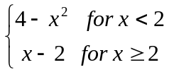  Show that f(x) is continuous at x=2 but not differentiable at x=2.  OR  If y = sin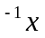, show that  i) 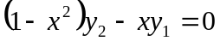  ii) 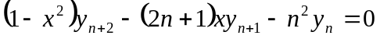  - State and prove Cauchy Mean value theorem.  Also verify Cauchy Mean value theorem for f(x) =x, g(x) = 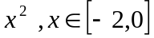 | 8  7
2. | - Evaluate 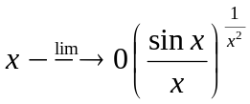  - A square piece of tin of side 18 cm is to be made into a box without lid, cutting a square from each corner and folding up the flaps to form the box. What should be the side of the square to be cut off so that the value of box is maximum possible?  OR  Find the radius of curvature at origin of the following curves. 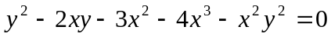 | 7  8
3. | Integrate (any three)  i) 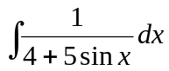 ii) 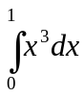 ( by the method of summation)  iii) 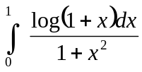 iv) 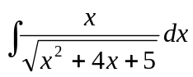 | 15
4. | a. Find the area bounded by the curve on the left by the parabola 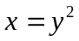 , on the right by the line y=x-2 and below by the x-axis.  OR  Find the volume of the solid generated by revolving the region bounded by 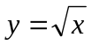and the lines below by y = 1, x = 4 about the line y = 1.  - Evaluate 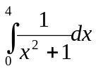by using Trapezoid Rule, Simpson's Rule and compare the result with the exact value taking n = 4. | 7  8
5. | - Find the condition that the line y = mx+c may be a tangent to the ellipse 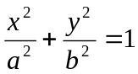.  - Derive standard equation of hyperbola in the form 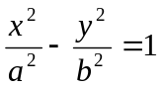 | 7  8
6. | - Find the equation of a plane through the points (1,2,3) and (3,2,1) and perpendicular to the plane 4x – y + 2z = 7.  - Define vector triple product and show that 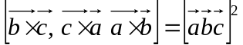 | 7  8
7. | Attempt all the questions:  - Find the domain and range of the function f(x) = 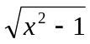  - Find vertical and horizontal asymptotes of y(x-1) = (x² -4).  - Find the arc length of the curve 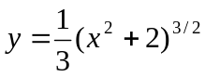  - Find the focus and length of latus rectum of the parabola x² + 8y – 2x = 7.  - Find the projection of the vector 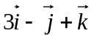on the vector 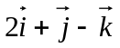 | 2×5

